 | Computer Organization and Assembly Language (EL-2003)
Semester: Fall 2025 Section: BCS-3J / BCS-3K
Course Instructor: Ms. Seema Hashwani

LAB # 07
Conditional Processing

Lab Objectives:
By the end of this lab, students will be able to understand:

- Boolean and Comparison Instructions
- Conditional Jumps
- Conditional Loop Instructions
- Conditional Structures

Boolean and Comparison Instructions

A programming language that permits decision making lets you alter the flow of control, using a technique known as conditional branching.

- AND Instruction
It is boolean AND operation between a source operand and destination operand. If both bits equal 1, the result bit is 1; otherwise, it is 0. The operands can be 8, 16, or 32 bits, and they must be the same size.

Syntax: AND reg, reg AND reg, mem AND reg, imm AND mem, reg AND mem, imm

The AND instruction always clears the Carry and Overflow flags. It modifies the Sign, Zero, and Parity flags in a way that is consistent with the value assigned to the destination operand.

NOTE: The All other instructions use the same operand combinations and sizes as the AND instruction.
- OR Instruction
It is boolean AND operation between a source operand and destination operand. For each matching bit in the two operands, the output bit is 1 when at least one of the input bits is 1.
mov al,11100011b
or al,00000100b ; result in AL = 11100111

The OR instruction always clears the Carry and Overflow flags. It modifies the Sign, Zero, and Parity flags in a way that is consistent with the value assigned to the destination operand.

XOR Instruction
The XOR instruction performs a boolean exclusive-OR operation between each pair of matching bits in two operands and stores the result in the destination operand. If both bits are the same (both 0 or both 1), the result is 0; otherwise, the result is 1.
The XOR instruction always clears the Overflow and Carry flags. XOR modifies the Sign, Zero, and Parity flags.

NOT Instruction
The NOT instruction toggles (inverts) all bits in an operand. The result is called the one’s complement.

Syntax: NOT reg
NOT mem

TEST Instruction
The TEST instruction performs an implied AND operation between each pair of matching bits in two operands and sets the Sign, Zero, and Parity flags based on the value assigned to the destination operand.
The only difference between TEST and AND is that TEST does not modify the destination operand.
Testing Multiple Bits: The TEST instruction can check several bits at once. Suppose we want to know whether bit 0 or bit 3 is set in the AL register. We can use the following instruction to find this out:

EXAMPLE
.code
mov | al, 10101110b |  | ; Clear only bit 3
and | al, 11110110b |  | ; AL = 10100110
mov | al, | 11100011b | ; set bit 2
or | al, 00000100b |  | ; AL = 11100111
mov | al, | 10110101b | ; 5 bits means odd parity
xor | al, 0 |  | ;PF=0(PO)
mov | al, | 10100101b | ; 4 bits means even parity
xor | al, 0 |  | ;PF=1(PE)

CMP Instruction

CMP (compare) instruction performs an implied subtraction of a source operand from a destination operand for comparison. Neither operand is modified.

Syntax:
CMP destination, source

Flags: The CMP instruction changes the Overflow, Sign, Zero, Carry, Auxiliary Carry, and Parity flags according to the value the destination operand.

When two unsigned operands are compared, the Zero and Carry flags indicate the following relations between operands:

  - Destination < source
  - Destination > source
  - Destination = source
ZF=0 CF=1
ZF=0 CF=0
ZF=1 CF=0

When two signed operands are compared, the Sign, Zero, and Overflow flags indicate the following relations between operands:
• | Destination < source | SF!=OF
• | Destination > source | SF=OF
• | Destination = source | ZF=1

Examples: Let’s look at three code fragments showing how flags are affected by the CMP instruction.

.code
mov ax, 5
cmp ax, 10 ; ZF = 0 and CF = 1
mov | ax, 1000
cmp | ax, 1000 | ;ZF=1 | and | CF =0
mov | si, 106
cmp | si, 0 | ;ZF=0 | and | CF=0

Conditional Jumps
- an operation such as CMP, AND, or SUB modifies the CPU status flags.
- a conditional jump instruction tests the flags and causes a branch to a new address.

Jcond Instruction
A conditional jump instruction branches to a destination label when a status flag condition
is true.
Syntax:
The conditional jump instructions can be divided into four groups:

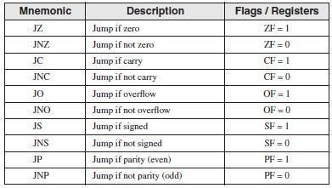
- Jumps based on Flag values

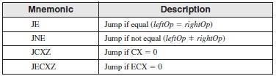
- Jumps based on Equality

- Jumps based on unsigned comparisons
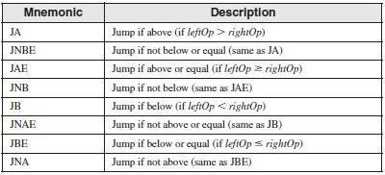

- Jumps based on signed comparisons

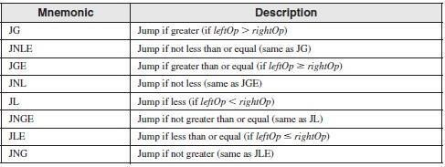
EXAMPLE
; This program compares and finds larger of the two integers

INCLUDE Irvine32.inc
.data
var1 DWORD 500
var2 DWORD 125
larger DWORD ?
.code
main PROC
mov eax, var1
mov larger, eax
mov ebx, var2
cmp eax, ebx
jae L1
mov larger, ex
L1:
exit
main ENDP
END main

EXAMPLE

; This program compares and finds smallest of the three integers

.data

.code

var1 DWORD 50
var2 DWORD 25
var3 DWORD 103
msg BYTE "The smallest integer is: ", 0
mov eax, var1 cmp eax, var2 jbe L1
mov eax, var2 L1:
cmp eax, var3 jbe L2
mov eax, var3 L2:
mov edx, OFFSET msg call WriteString
call crlf
call WriteDec call crlf
exit

Conditional Loop Instruction

- LOOPZ and LOOPE Instructions
The LOOPZ (loop if zero) instruction works just like the LOOP instruction except that it has one additional condition: The Zero flag must be set in order for control to transfer to the destination label.
The syntax is

LOOPZ destination
The LOOPE (loop if equal) instruction is equivalent to LOOPZ and they share the same opcode.

- LOOPNZ and LOOPNE Instructions
The LOOPNZ (loop if not zero) instruction is the counterpart of LOOPZ. The loop continues while the unsigned value of ECX is greater than zero (after being decremented) and the Zero flag is clear.
The syntax is LOOPNZ destination
The LOOPNE (loop if not equal) instruction is equivalent to LOOPNZ and they share the same opcode.
Example:
; The following take input from user until user press 0
.code
mov ecx,5 L1:
CALL readInt cmp eax, 0 LOOPNZ L1
call DumpRegs

Conditional Structures
We define a conditional structure to be one or more conditional expressions that trigger a choice between different logical branches. Each branch causes a different sequence of instructions to execute.

- Block-Structured IF Statements
An IF structure implies that a boolean expression is followed by two lists of statements; one per-formed when the expression is true, and another performed when the expression is false.
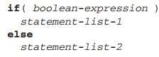

If structure: In High level Vs Assembly Language
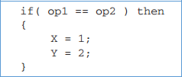

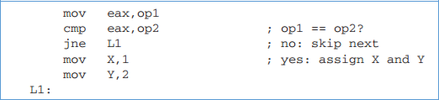

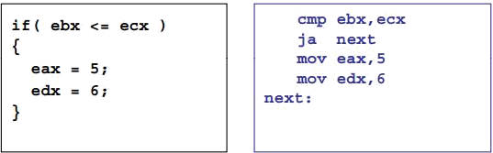

If-else structure: In High level Vs Assembly Language
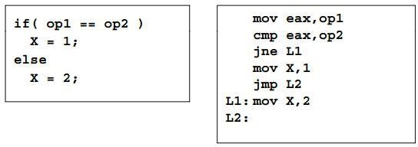

Compound Expression with AND
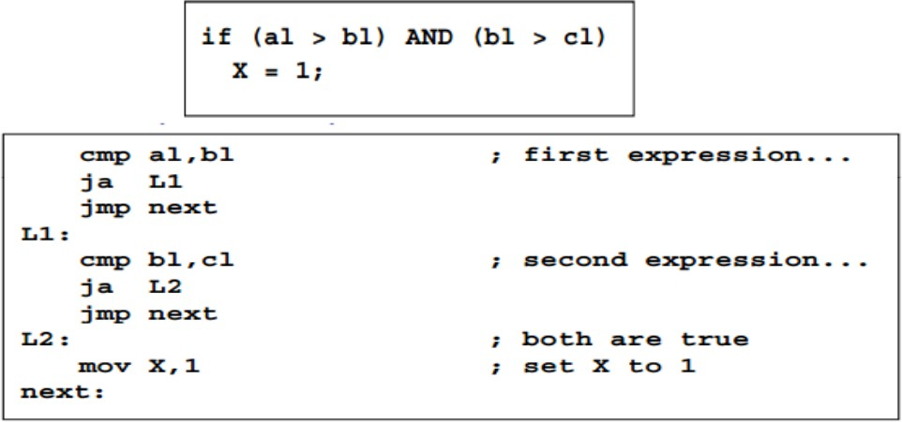
When implementing the logical AND operator in compound expression, if the first expression is false, the second expression is skipped.

Compound Expression with OR
When implementing the logical OR operator in compound expression, if the first expression is true, the second expression is skipped.
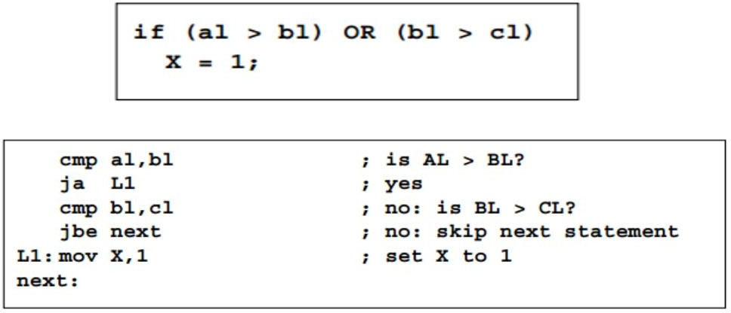

- While Loops
A WHILE loop is really an IF statement followed by the body of the loop, followed byan unconditional jump to the top of the loop.
